Pack your bags...
- Read the scenario. It gives you information about who you are and the question to answer.
- Use the geographical inquiry process to complete steps 2-4.
Step 1 – Your question – Which city is the most liveable for you, Berlin or New York?
Scenario:
You cannot believe your luck. You work for a company with overseas branches in New York and Berlin. They are offering you a two-year contract overseas. You get to choose which of these cities you want to live in.
About you:
Single and 25 years old, you have never travelled overseas. You like open spaces, outdoor activities and sport. In Australia you do a lot of water sports, soccer and cycling. You have always wanted to visit the “Big Apple” but love the idea of skiing in Europe, and you like cold climates. You want to do a lot of travelling to visit as many countries as you can. The company pays you well for your age but you will have to be careful with your spending. You love history and geography, so visiting museums, historical sites and interesting places is important to you. You only speak English but learnt a bit of German at school. The company will fly you to your destination and home again at the end of your contract. You have seven days to make a decision.
Step 2 – Collecting, recording, evaluating and representing data.
Investigate New York and Berlin using the information provided and research on the internet. You could look up official tourist sites, info graphics and blogs from Australians living there. You need information on location (including neighbouring countries and distance from Australia), climate, transportation, cost of living (affordability), language, entertainment, recreation, places of interest to visit (cultural and natural environments).


Put your information into a table as you collect it. Think about which liveability criteria are most important to you.

Step 3 – Analyse
You should do a SWOT analysis for each location before making your decision. Divide a page into four sections. Label them Strengths, Weaknesses, Opportunities, and Threats.
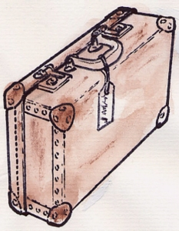
Draw a conclusion about which place best suits your needs. Which place is most liveable for you? Make your decision.
Step 4 – Communicate
To help the next person from your company facing the same choice, present your judgement about the liveability of New York and Berlin using ICT tools such as;
- PowerPoint
- Poster
- Info graphic
- A report for a travel magazine with text, graphics, pictures and using a publishing template.
Below is a space for your Brainstorm about the task.
.

